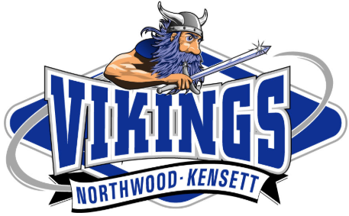
2026 ATHLETIC HALL OF FAME NOMINATION FORM
Guidelines for Nominations are as follows:
*All nominations must be received by April 15th, 2026.
*All nominations must be in writing. Mailing address found at bottom of the page.
*Nominees who were student-athletes must be a graduate of Northwood-Kensett High School & must have graduated a minimum of 10 years prior to be inducted.
*If a team is nominated, that team must have accomplished regional or state level achievements.
*Nominees must be a former or current coach, administrator or deserving community member/volunteer to N-K Athletics.

Your (Nominator) Information (in case the committee needs to contact you for verification)
Name: _________________________________________________________________ Date Submitted: _______________________
Phone: ____________________________ Email: ____________________________________________________________________
Nominee Information:
PLEASE CHECK BOX: Student-Athlete Team Coach Administrator/Community Member/Volunteer
Name: _________________________________________________________________ Graduation Year from NKHS: _____________
Maiden Name (if applicable): ____________________________________________________________________________________
Address: _________________________________________________________ City: _____________________________ St: ______
Phone: _____________________________ Email: ___________________________________________________________________
Reason for Nomination Consideration
____________________________________________________________________________________________________________________________________________________________________________________________________________________________________________________________________________________________________________________________________________________________________________________________________________________________________________________________________________________________________________________________________________________________________________________________________________________________________________________________________________________________________________________________________________________________________________________________________________________________________________________________________________________________________________________________________________________________________________________________________________
Please complete and mail form to: Northwood-Kensett Hall of Fame Committee, PO Box 133, Northwood, IA 50459

